*Below described guidelines are to be used by the project team to develop a technical solutions (selection of protection measures) in accordance with the following points, aimed at minimizing the risks that may occur at the construction phase at the project.*

*Drawings with diagrams of technical solutions should be included as a part of the excution design.*

1. **Securing work at heights** by using a system barriers (especially choosing the appropriate type of the post base depending on the surface type to which it will be fixed) with a steel mesh panels, eg TLC supplier catalogue - ceiling edges, balconies, lift shafts, ceiling openings, installation shafts; - in the scope of the detailed design or tender- executive design, a description of the recommended solutions at the construction stage with the formworks and after the formworks disassembly, and secured areas to be indicated.

Obraz zawierający budynek, wewnątrz, płot

Opis wygenerowany przy bardzo wysokim poziomie pewnościObraz zawierający niebo, zewnętrzne, płot, pociąg

Opis wygenerowany przy bardzo wysokim poziomie pewności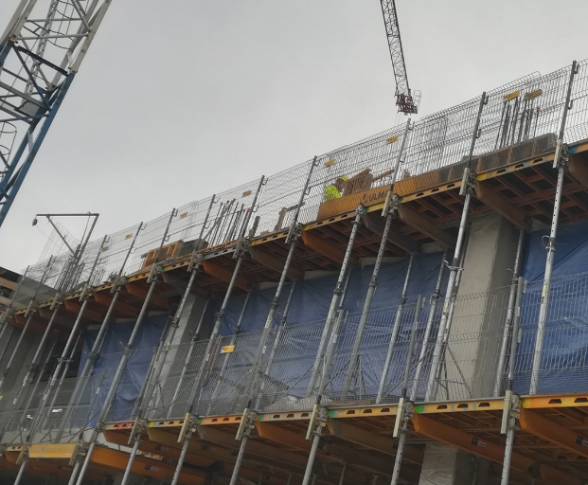

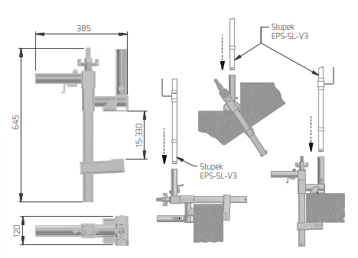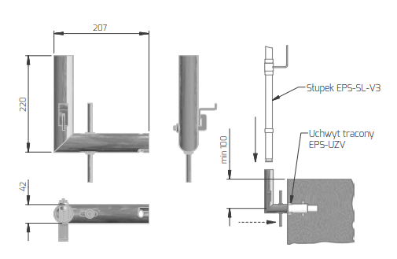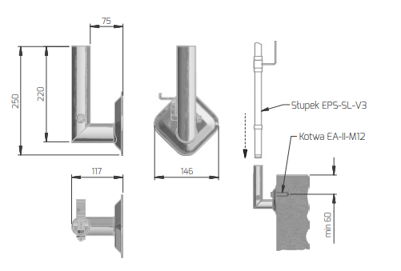

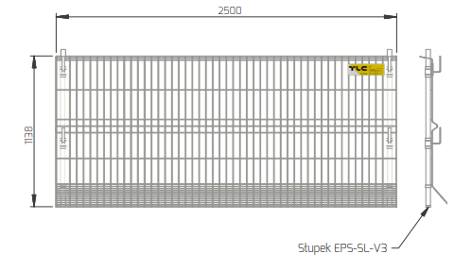

1. **Shafts / technological openings;** use of platforms, system barriers, covering of holes - a general guideline for opening holes in the execution design project of the structure and architecture of the shell - on the formwork drawings and on the drawings of the walls that all endangered places should bepermanently **secured to prevent tripping, unintended movement the protection covering or falling. Indicate on the drawings the areas at risk with an area greater than 1 m2. Other places are the subject to the note on the need to be secured.**

The required solution is the use of system brackets (holders, i.e. Secumax by Forbuild) for temporary working platforms in elevator shafts and openings.

**Obraz zawierający budynek, podłoże, ściana

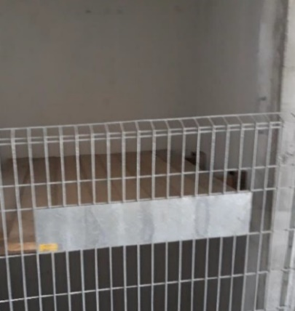 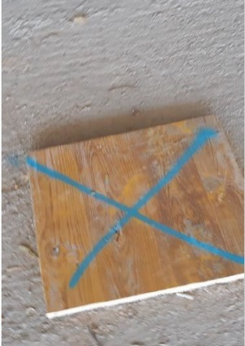**

**.** 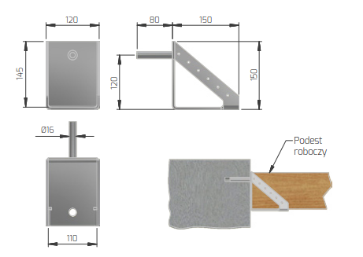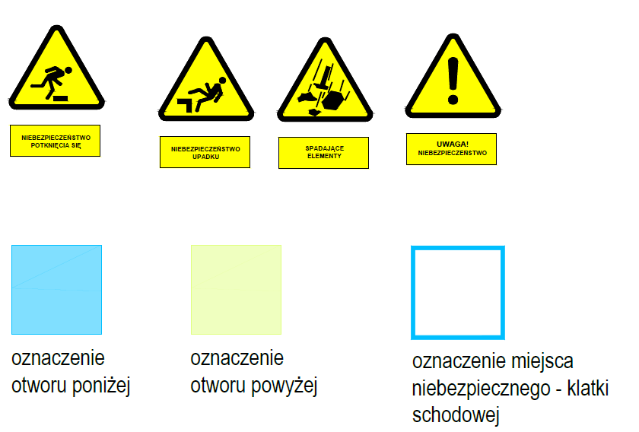

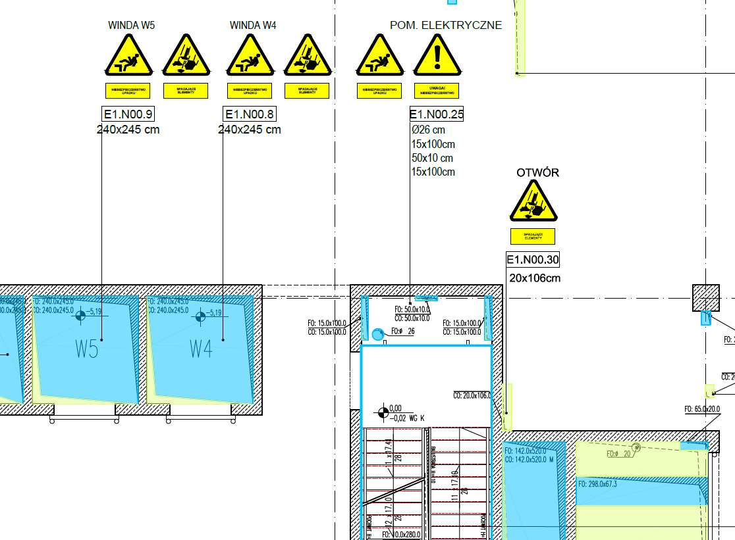

1. **installation shaft,** raised reinforced concrete / masonry wall around the opening; In case of reinforced concrete shaft technology, staging should be planned in such a way that the openings with an area greater than 2 m2 were erected with the target wall. In other cases temporary barriers have to be provided, such as used on balconies, e.g. with grips clamping the ceiling thickness.

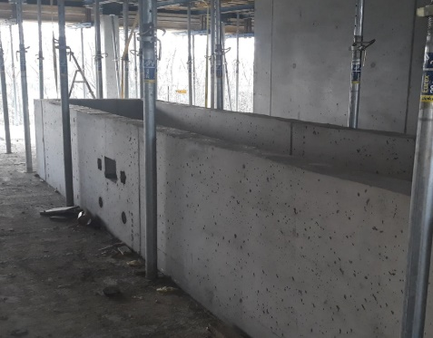

Near the each shaft with an area more than 1m2, anchor points to be indicated (e.g. Protekt AZ 640 anchor tapes attached to the bottom reinforcement mesh). Consider the offset of the anchorage point from the edge of the shaft.

1. **balconies / terraces / loggias (if any)** prefabricated and monolithic balconies with temporary system barriers – based on TLC supplier catalogue (or equivalent supplier, after agreeing with Echo)
   1. in prefabricated balconies, provide for the installation of temporary edge protections in the anchor fixing points dedicated to permanent balustrades,
   2. in monolithic balconies, foresee the necessity to install temporary system protections components to the formwork, and after the formwork disassmelbng, the solution should be immediately applied as for prefabricated balconies.
   3. in the case of loggias or terraces, in particular, the type of socket (of the post) and the method of its assembly to the structure (depending on whether there are attics / walls or not)

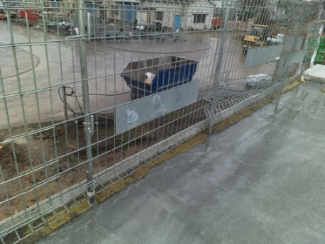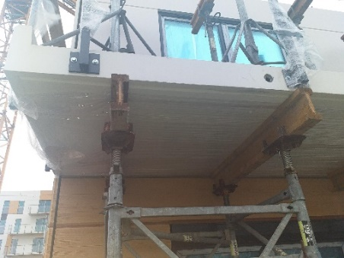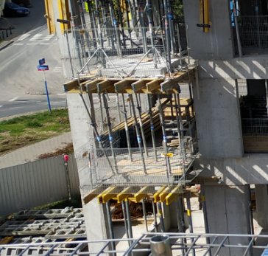

1. **staircases –**
2. temporary system barrier – to be determined as the notes on the drawings, if possible - recommended solution for installing temporary protection in the anchor fixing points dedicated to permanent balustrade - select an example of a compatible anchor fixing points for the temporary and permanent solution.
3. in the case of staircases - stair flights without finishing (solid concrete), indicate the method of mounting the clamping sockets for the installation of posts and temporary system barriers,

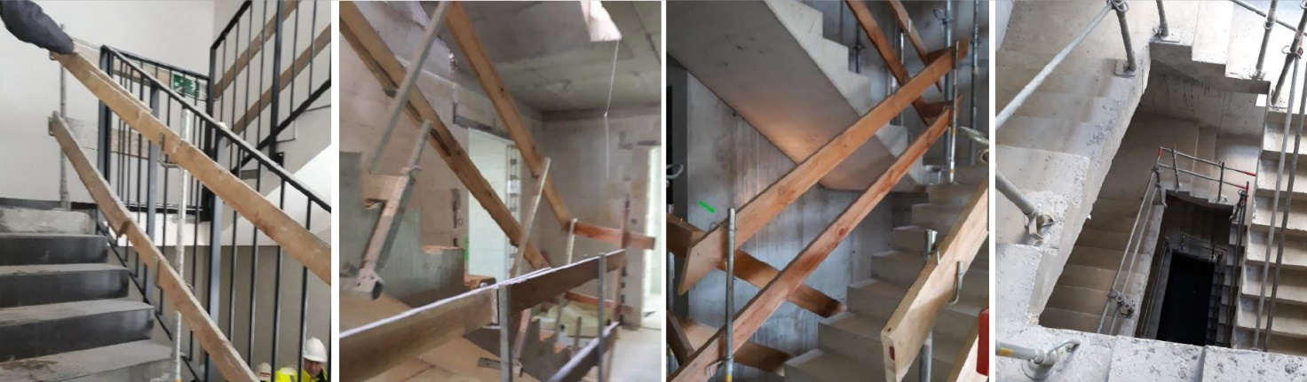

1. **Flat roofs**

It is required to take into account permanent safety fall protection system on the roof, mounted to the flat roof structure (before laying the final layers of thermal / anti-water insulation) - it is required to use systems compliant with PN-EN 796 type C (fixed rope system) or PN-EN 795 type A (permanent anchor points).

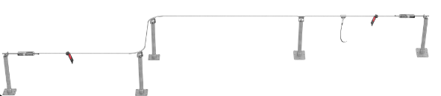

An example of a permanent rope system solution according to PN-EN 795C

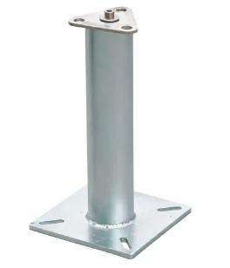

An example of a solution of a fixed belay point according to PN-EN 795A

**Note!**

According on obligatory ECHO standards, the system edge protection includes following components:

- system fixing point base,

- system post,

- system metal mesh panel.

